Module Assembly - Topcoder NodeJS Challenge Results API v1.0 Deployment Guide

Revision History
Author | Revision Number | Date
kurtrips | 1.0 | 2014/02/06
Deployment Instructions 4
1.Organization of Submission 4
2.Application Setup 4
2.1.Preconditions 4
2.2.Build Script Setup 4
3.Database setup 5
4.Configurations 6
5.Deployment Instructions 6
8.Resource Contact List 11

Deployment Instructions

Organization of Submission
The folder structure (the root directory of the submission is referred as the <base> throughout the document)
Name | Description
tc-api/ | Main application source code of this assembly.  Contains only new or changed files.
tc-api/doc/Module Assembly - TopCoder NodeJS Challenge Results.doc | This file.

Application Setup

Preconditions
- Linux 64bit System (preferably the Ubuntu 10.04), which is used by Heroku stack for Nodejs), with development tool, such as g++, maker.
- Informix Client SDK (used to connect remote Informix Server)
- NodeJS 0.10.21 http://nodejs.org/
- NodeJS-DB-Informix https://github.com/amitkr/nodejs-db-informix
- Git
- Heroku Account and Toolbelt
  - Signup a Heroku account in https://api.heroku.com/signup/devcenter with your email address.
  - Download the Heroku Toolbelt from https://toolbelt.heroku.com, and make sure the Heroku CLI is working in your environment by typing the “heroku help”.
  - Login your Heroku account by typing the “heroku login”.
This requires you to input your email and password, and then finally it will upload your public SSH key to the server so that you don’t have to provide your credential during the subsequent commands.
If you have a “Permission denied (publickey)” error during deployment, you can use “heroku keys:add” to add the public key to the remote repo as described here.

Build Script Setup
Two BASH scripts are used to ease the deployment.
- deploy/development.sh
It helps to launch the application locally.
It simply exports the configured environment variables and then launch the Node.js application.
- deploy/heroku.sh
It helps to deploy the application onto the Heroku cloud.
It has command line switches.
Switch | Description
clean | It cleans the current repository information by simply removing the .git folder.
commit | It initializes the local repository and commits all the current project files, if the current directory is not a GIT repo yet; or commit all the changes to the local repository, if the current directory is already a GIT repo.
create | It creates a Heroku app for the current logged-in Heroku account.  This app will only be used if it is created when the current local GIT repo has not yet setup the remote repo of name “heroku”.  If your local repo has already setup “heroku” remote for an existing app, this app will not be picked as the target app for other Heroku commands. If you want to create an new Heroku app and use it as the target app in this case, you can clean and re-initialize the current local repo first, or you explicitly rebase it to the new Heroku app.
config | It exports all the configured environment variables to the target Heroku app.
push | It pushes the current committed version to the “heroku” remote.
launch | It launches one Heroku dyno to run the target app.
all | It will execute all other steps in the order: “clean”, “commit”, “create”, “config”, “push”, and then “launch”.
deploy | It only executes the steps to deploy the projects to the Heroku cloud: “config”, “push”, and then “launch”.  It assumes the code has been committed to the local repo, and the local repo has setup the “heroku” remote for the target app.

Database setup
NOTE: These steps are not necessary if you first run mocha test on localhost (see step 6.2) and later test on heroku.

- Upload the submission to /mnt/shared/temp_files/
- Login vm as ‘tc’ account
- cd /mnt/shared/temp_files
- unzip submission.zip
- su informix -l
- cd /mnt/shared/temp_files/submission/tc-api/db_scripts
- Run from command line dbaccess the script to insert the test data.
dbaccess – challenges_results.insert

There is also a 'challenges_results.delete' to clean the data.

Configurations
There are two BASH scripts used to ease the deployments and launching of the application.
The configurations are defined in these scripts to export the environment variables.
One of them is for local development “tc-api/deploy/development.sh”, where the configurations are defined.
Please replace TC_DB_HOST and TC_DW_HOST with your VM IP
export TC_DB_HOST=50.16.28.22
export TC_DB_PORT=2021
export TC_DB_USER=informix
export TC_DB_PASSWORD=1nf0rm1x
export TC_API_HOST=api.topcoder.com

export TC_DW_NAME=informixoltp_tcp

export TC_DW_HOST=50.16.28.22

No changes are required to tc-api/deploy/heroku.sh.
Additionally the TC_DB_HOST and TC_DW_HOST in “tc-api/deploy/development.sh” needs to be changed to your VM IP address as well.

Deployment Instructions

- Setup heroku in section 2.1 and database in section 2.3.
- Run git clone git@github.com:cloudspokes/tc-api.git. Use the commit number 8ddf39334d81ebfa186fe10b89c600e58463fc42
- Copy all files from submission/tc_api to checked out tc-api and override all files
- Replace db_host as defined in section 4.
- Go to tc-api folder (if not already) and run npm install
- To deploy application in heroku, run:
  - chmod +x deploy/heroku.sh
  - . deploy/heroku.sh all
  - After running the script, you can use “git remote -v” to see the “heroku” remote repo. The remote repo will be like git@heroku.com:<app-name>.git, you can know the create app name here.
- To deploy application in local environment, run:
  - chmod +x deploy/development.sh
  - . deploy/development.sh
  - npm start
  - Server is listening on port 8080.

- Verification by tests
  - Js lint
Install the node-jslint in your local environment globally by “sudo npm install jslint -g".
Check the following files (which contain the application code) under the <base>/tc-api
jslint -nomen actions/challenges.js
jslint -nomen config.js
jslint -nomen routes.js
The “tests” are not application code so they don’t have to pass the JSLint rules.

  - mocha
Run “node_modules/.bin/mocha test/test.challengeResults.js” from within the “<base>/tc-api/” directory.
There are 18 tests which should all pass.

- Verification by pages
Please check docs for full parameter description. Here http://docs.tcapi.apiary.io/

Get Development Challenge Results

Example http://infinite-inlet-9251.herokuapp.com/v2/develop/challenges/result/66901

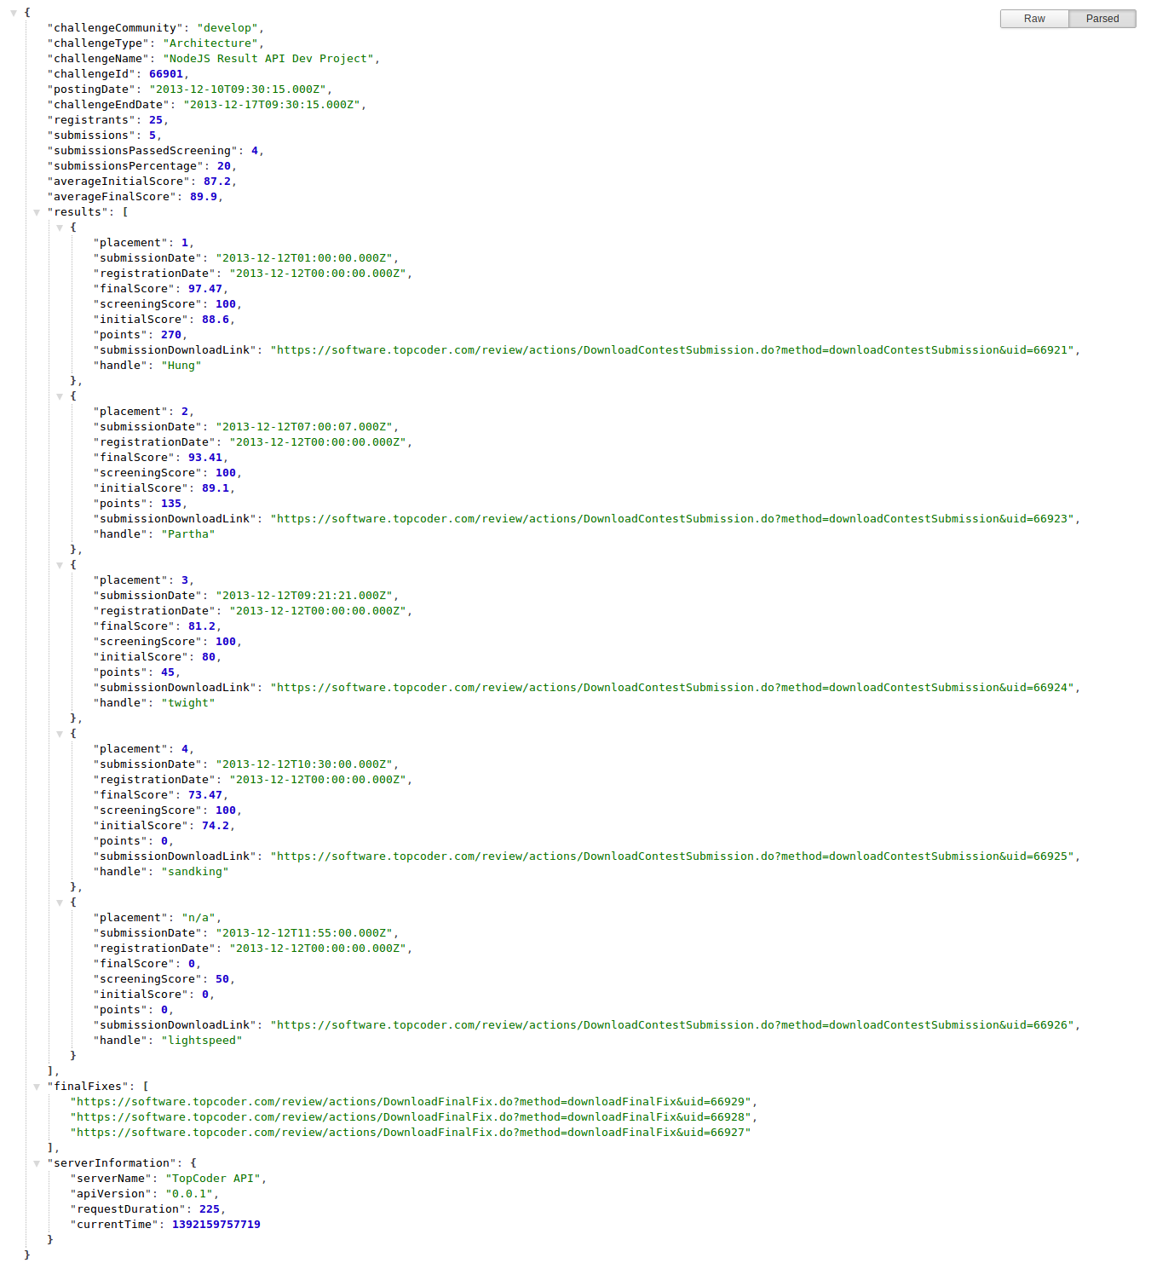

Get Design Challenge Results (submission and coders not viewable)

Example http://infinite-inlet-9251.herokuapp.com/v2/design/challenges/result/66902

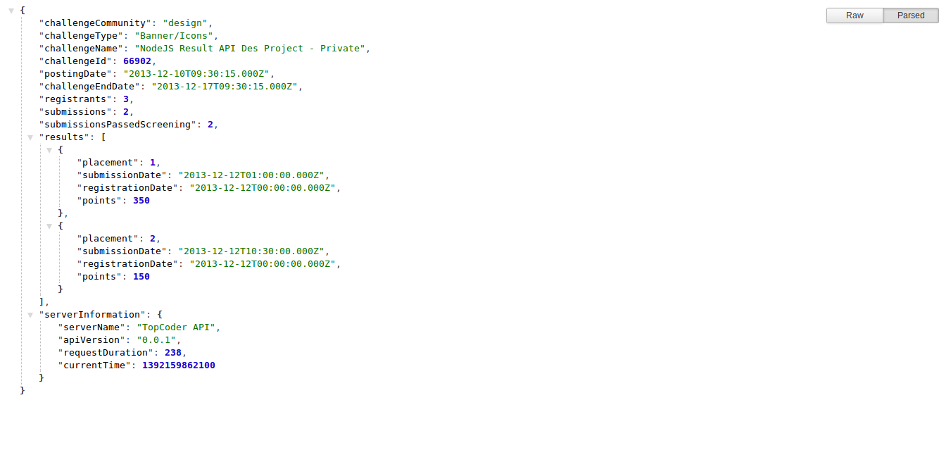

Get Design Challenge Results (submission and coders are viewable)

Example http://infinite-inlet-9251.herokuapp.com/v2/design/challenges/result/66913

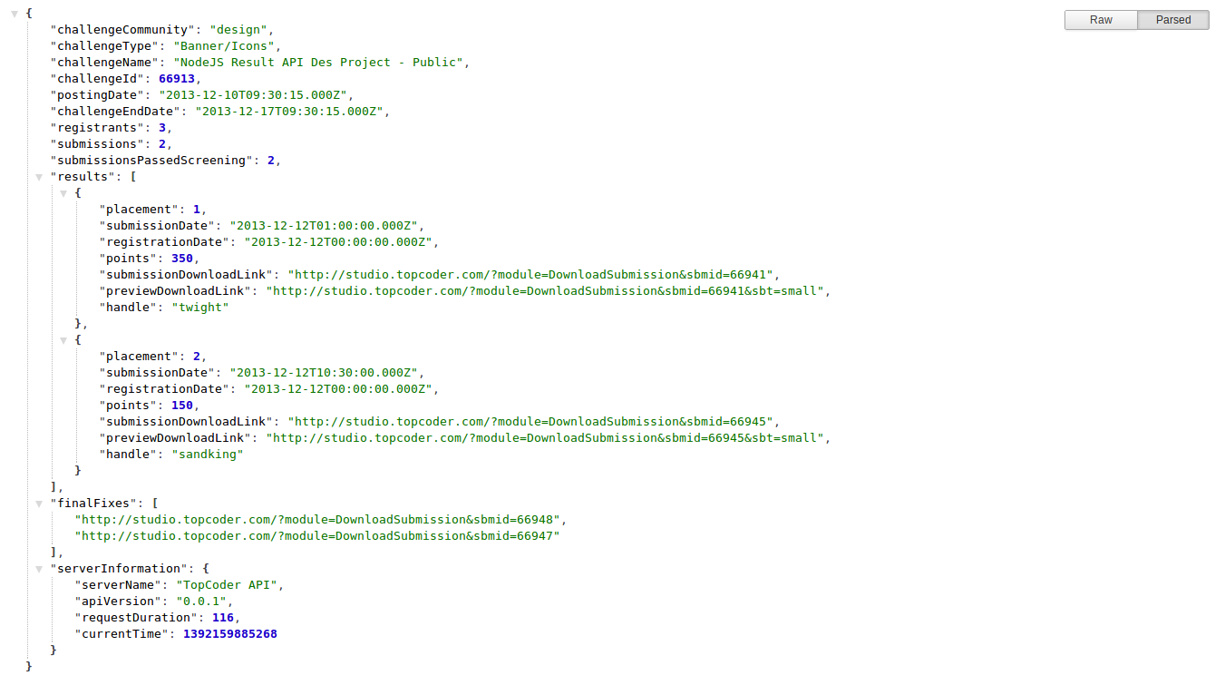

Get Design Challenge Results (private contest)

Example http://infinite-inlet-9251.herokuapp.com/v2/design/challenges/result/66914

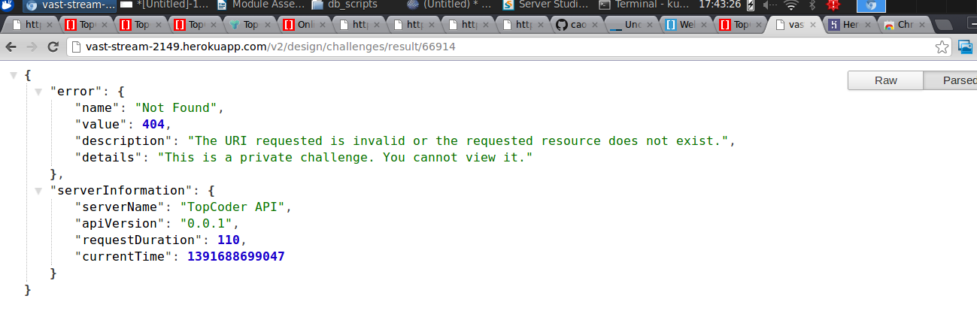

Get Design Challenge Results (unsupported contest type – for example Spec Review, Marathon Match, Copilot Postings etc)

Example http://infinite-inlet-9251.herokuapp.com/v2/develop/challenges/result/66910

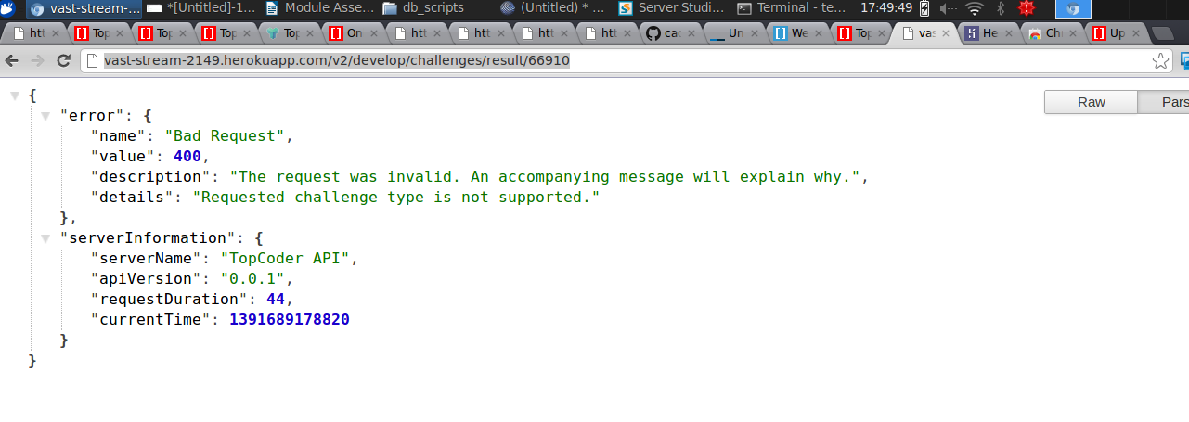

Get Design Challenge Results (contest not closed properly – for example still active, cancelled by client, cancelled due to zero submissions)

Example http://infinite-inlet-9251.herokuapp.com/v2/develop/challenges/result/66907

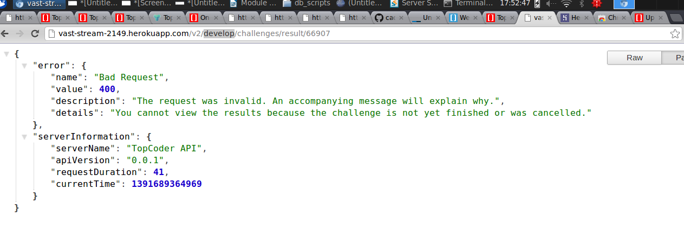

Resource Contact List
Name | Resource Email

